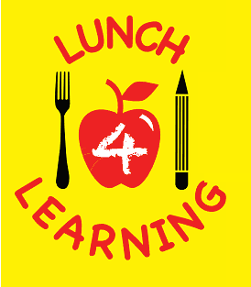 | 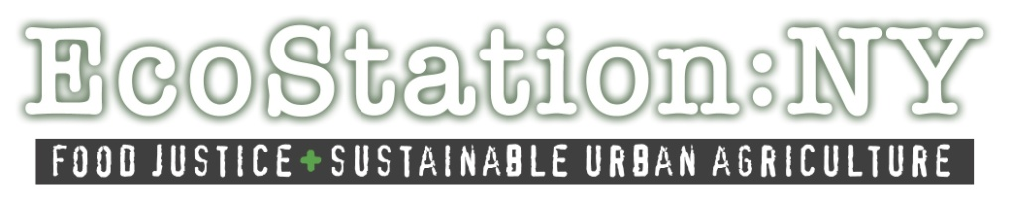

#Lunch4Learning Selfie Campaign
Lunch 4 Learning is a campaign for universal free school lunch for all NYC public school students. High school students from EcoStation:NY, Make the Road NY, and The Bushwick Campus Youth Food Policy Council have launched this “selfie” campaign so that we can hear from those that feel universal free school lunch is a beneficial policy. This is open for everyone to participate in, including students, parents/guardians, teachers, etc.
Your voice is important to us!
Here is how this works:
- Download and print the template.
- Express why you are the voice of universal free school lunch by filling out the template.
- Snap a photo of you with your personalized written template.
- Post & share your “selfie” with your social media network (i.e. facebook, twitter, instagram, etc.)
- Remember to hashtag your post with #Lunch4Learning.
- Spread the word

Feel free to tag Mayor de Blasio to let him know how important universal free school lunch is in New York City.
Twitter @BilldeBlasio Instagram @billdeblasio Facebook @Bill de Blasio

How to post #Lunch4Learning “selfies”

Facebook & Twitter via smartphone (iPhone and Android)
- Take a photo with your camera phone
- Open up photo on screen and click the share option
- Choose which social media site you’d like to share your “selfie”
  - Write the following:
    - Twitter - @billdeblasio I am the voice for universal free school lunch b/c _____________. #lunch4learning
    - Facebook - @Bill De Blasio I am the voice for universal free school lunch b/c ____________. #lunch4learning

Instagram via smartphone (iPhone and Android)
- For instagram, you will need to open up the app first
  - Click on camera logo
  - Add photo from your camera’s photo gallery
  - Write the following:
    - @billdeblasio I am the voice for universal free school lunch b/c________. #lunch4learning

For organizations/events
You can post other people’s “selfies” on your organization’s social media accounts, using the same directions as above. Remember to direct it to the mayor and hashtag #lunch4learning.

Thank you for your participation in this social media campaign!

